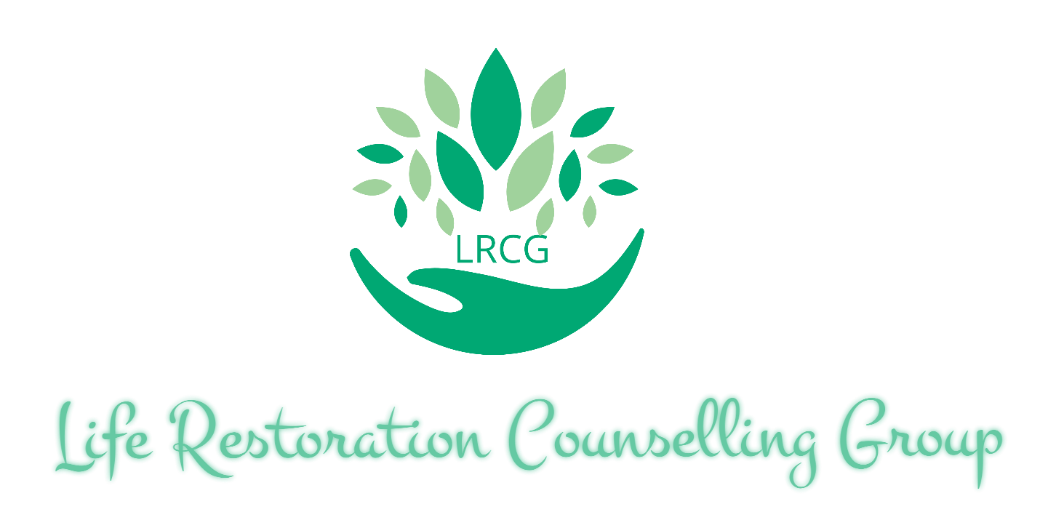

Client Welcome Package

Table of Contents

p.3 How Can We Help
p.4 The LRCG Therapeutic Model
p.5 “Getting To Know You” Questionnaire (also available via the website)
p.6 Confidentiality Agreement
p.7 Fees of Service
p.8 Insurance Coverage and Payment
p.9 Client Signature Page

How Can We Help

At LRCG we are striving to change the face of counselling and assist individuals, couples and families in attaining their self-determined goals by rejuvenating and restoring themselves and their relationships. We help with a variety of issues and difficulties such as:
- Anxiety
- Depression
- Marital or relationship issues
- Parenting
- Addictions
- and other issues that may affect the quality of your life
At LRCG we respect that people who seek counselling have busy lives and reside in a technologically advanced environment. We currently offer:
- Telephone counselling
- video-calling sessions
- and face-to-face counselling sessions
As part of healthy growth, we plan to expand our options for counselling to include mediums such as email, text message and other instant messaging applications.
The counsellors at LRCG have extensive experience in the community of social services and mental health which has created an awareness of the gaps in service for people seeking counselling today. In keeping with our mission to change the face of counselling, we will be expanding our team in order to attain our goal of creating the opportunity for people who utilize our service to be referred to other counsellors within LRCG. This interagency referral system will cut down wait times to see a specialized counsellor and allow for the LRCG counsellors to work together in providing the best service to you.
Our hope for you, is that we can provide a counselling experience that not only restores your life and relationships, but also enables you to have a positive impact within your community.

The LRCG Dynamic Therapeutic Model

- Counselling sessions (in office/video/telephone)
- At home activities and work to support the process of the therapy
- Involvement of a family member or kin relative at a session to create a comprehensive counselling experience
- A medical or psychiatric referral in order to rule out any other possible contributing factors

Getting To Know You
Full Name: ________________________________________________________
Date of Birth: __________________________________
Address: _________________________________________________________________
Postal Code:___________________________
Phone #: ____________________________________
Can you receive confidential voicemail message on the number provided? YES NO
Email: ________________________________________________________________________________
Please circle and answer the following questions.
- Have you attended counselling before? Yes No
  - If so how would you rate your previous experience 1-10 (10 being very good) ____________________________________
- Did you seek out counselling support on your own, or were you encouraged to do so by family/friends/it was required? ____________________________________________________________________________________________________________________________________________________
- What are your top 3 fears or worries about seeing a counsellor?

- Name 3 areas of your life or difficulties that you currently face that you would like to address in counselling.

Confidentiality Agreement

‘‘Principle V, Confidentiality of the Code of Ethics and Standards of Practice is of relevance:
5.1 College members comply with any applicable privacy and other legislation.
College members obtain consent to the collection, use or disclosure of client
information including personal information, unless otherwise permitted or
required by law.
5.3.1 When College members are employed by an agency or organization,
College standards of confidentiality may conflict with the organization’s policies
and procedures concerning confidentiality. Where there is a conflict, College
standards take precedence.
5.3.6 College members do not disclose the identity of and/or information about a
person who has consulted or retained them unless the person consents. Disclosure
without consent is justified if the disclosure is required or allowed by law.‘‘
(OCSWSSW, Code of Ethics and Standards of Practice).

At LRCG we uphold the requirements set out by the Ontario College of Social Workers and Social Service Workers (as noted above). We will ensure complete confidentiality of our client’s information disclosed during our sessions and our records unless there are extenuating circumstances such as:
- You make a disclosure relating to harming yourself or another person
- There are concerns relating to the safety and well-being of a child (see Section 72 of the Child and Family Services Act)
- It is required by a designated authority (i.e. Police Services)

Children over the age of 12 may consent to counselling and have their confidentiality respected except in the case of extenuating circumstances as stated above. Children under the age of 12 must have both parents sign a consent form prior to the commencement of counselling. Should one parent have sole custody, LRCG counsellors must have proof of the court order.

Clients may consent to LRCG counsellors speaking to family members, doctors, schools etc through signing a release of information. The consent form will be provided to you and will be kept on file.

Fees of Service
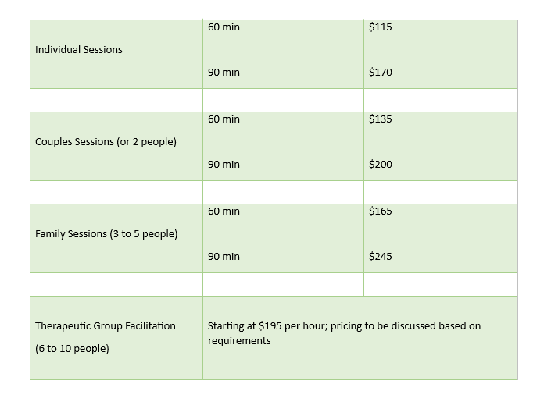
* The above rates do not apply to LRCG Consultants, as they set their own rates/fees *
Important notes:
- Social Work services are HST exempt
- Home visits have a $20 fee (available within 10 km of the office).
- Any other services in excess of 15 minutes (i.e. report writing or contact with other professionals) will be billed at the usual hourly rate and will be discussed with you in advance.
- Rates are subject to increase January 1 of each year. Active clients will be notified via email of increased rates with a 30 day notice. Please speak to your counsellor regarding financial constraints.

- LRCG counsellors require 24 hours notice of a cancelled appointment. Should sufficient notice not be provided, the full scheduled appointment will be charged.
- Sessions are considered missed after being late by 20 minutes. Missed sessions are considered cancelled without notice.

Insurance Coverage and Payment
FORMS OF PAYMENT:
LRCG counsellors are accepted by most extended health benefits insurance providers. Payment by the client is received first and you are then reimbursed by your insurance provider. We accept cash, electronic money orders (required prior to the beginning of the session), VISA, Mastercard, American Express and Discover via point of sale readers.
Please contact your insurance provider to verify coverage prior to our first session.
You can ask some of the following questions when contacting your insurance provider:
- Do I have coverage for a registered Social Worker for counselling services?
- How many sessions per year does my health insurance cover?
- What is the coverage amount per therapy session?
- What is the amount of my annual coverage?
- What is my deductible for each session? ​
- Is approval required from my primary care physician?
Social Work services are not covered by OHIP, however are considered a medical expense tax credit for income tax purposes. Any fees not covered by your benefits plan can be claimed when you file your income tax return.
Please note: late payments (longer than 24 hours after the session time) may be subject to a late payment fee of $25

Client Acknowledgement and Signature

I hereby certify that I have read this counsellor’s disclosure agreement as well as all documents provided. I understand the contents of these documents and agree to the terms set forth therein.

Client signature: ___________________________________________________________ Date: ____________________________________________________________________________________

